HARDWARE

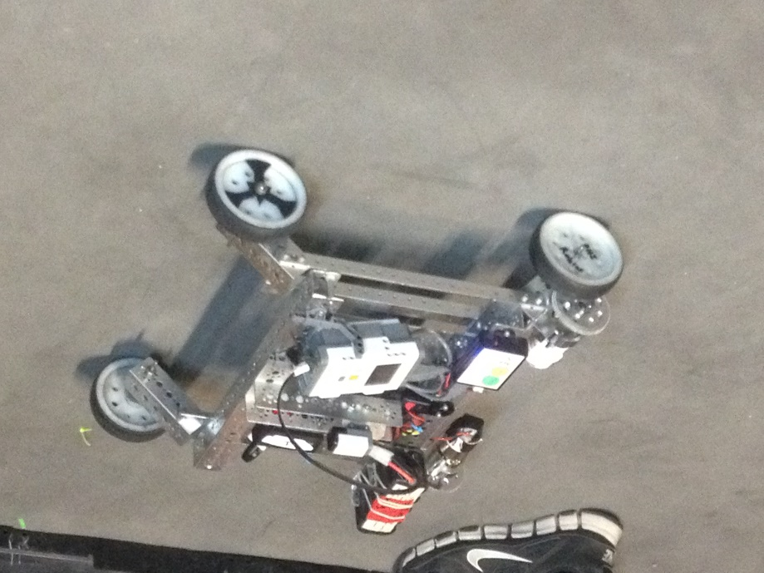
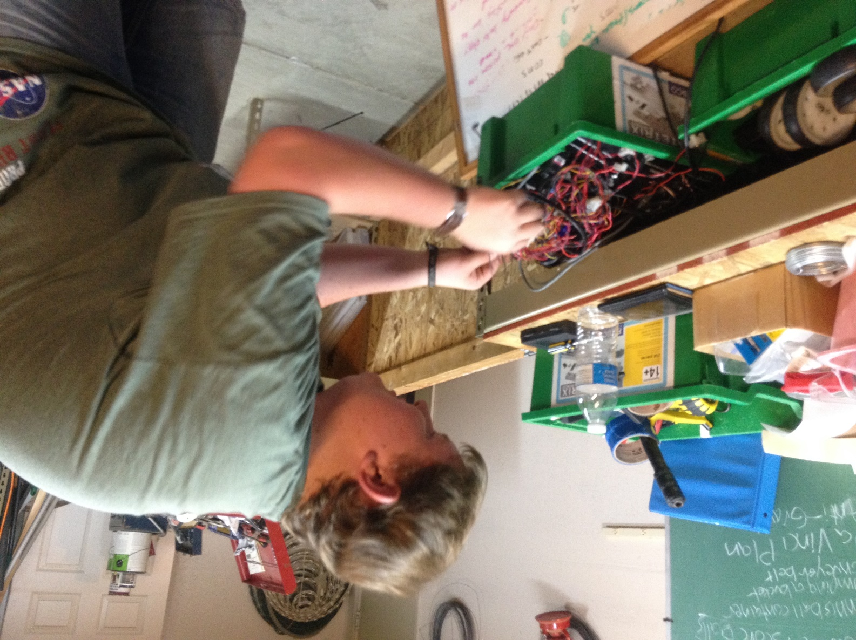
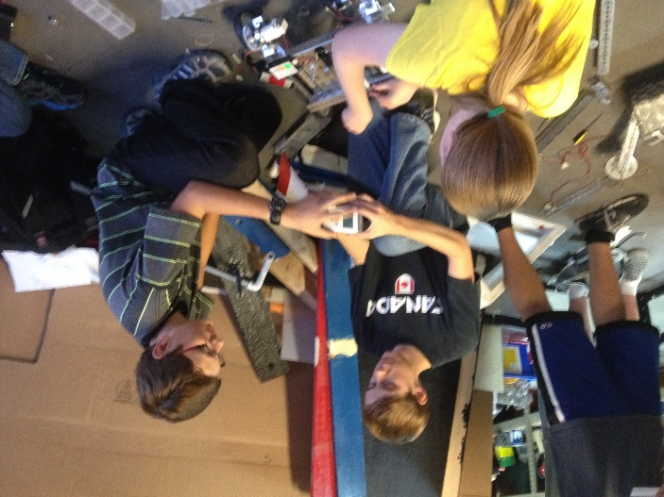

KHAN'S LOG

Robotics: the final frontier. These are the adventures of the robotics team PHI Omega. Its ongoing mission: to explore strange new ideas, to seek out new designs and new mechanizations, to boldly go where no team has gone before.
For the 2014-2015 FIRST tech challenge year, PHI omega has committed itself to excellence and to go above and beyond the challenge. In this spirit PHI omega has set out to build a robot superior in every way: from hardware to sensors to software. It is for this reason that we have decided to name our robot "Khan", a robot that, in the words of its namesake, is better at "everything."



Khan's log
Star date 6/7/14
In order to build a superior robot, our team has opted to start work early. We have chosen to start with an improved chassis.
Chassis design requirements:
- It should be based on a proven design
- It should be predesigned
- It should be modular
- It should have high mobility
- It's wiring should be clean and accessible
To meet these requirements we began by reevaluating our traditional "Kraken" chassis that was designed five years ago by a former team member.
Pros:
- High ground clearance
- Fairly modular
- lightweight and rigid Last year's "Kraken" under deconstruction
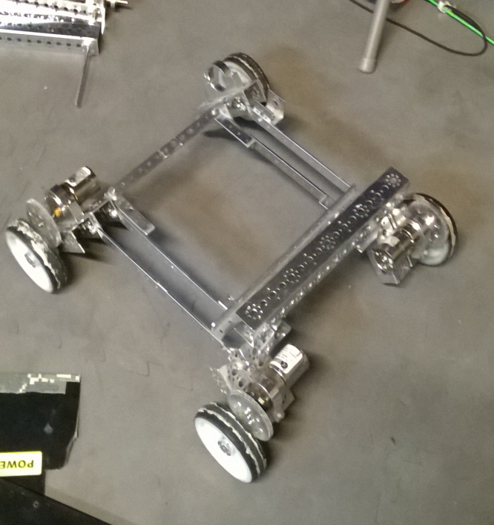
Cons (no pun intended):
- It requires some parts that we no longer have sufficient amounts of
- 45 degree motor nacelles tend to warp throughout the year
After brainstorming about the chassis for some time we have decided on a few features that could improve the old Kraken chassis.
- Single piece 3D printed or metal shop frame
- Fully enclosed nacelles rather than open C-channels
- Integrated suspension to cushion the sensors and electronics
Khan's log
Star date 6/27/14
For the last week all the FIRST teams in the valley from FTC and FRC have gathered at a local middle school to host a robotics workshop for local middle school students teaching them robotics basics using the VEX robotics system. During the last week we have had the chance to get some advice from our fellow teams on computer aided design. One of the teams recommended that we look into using Auto Desk CAD software.
The VEX robot named "Colonel Sanders" that won the workshop championship.
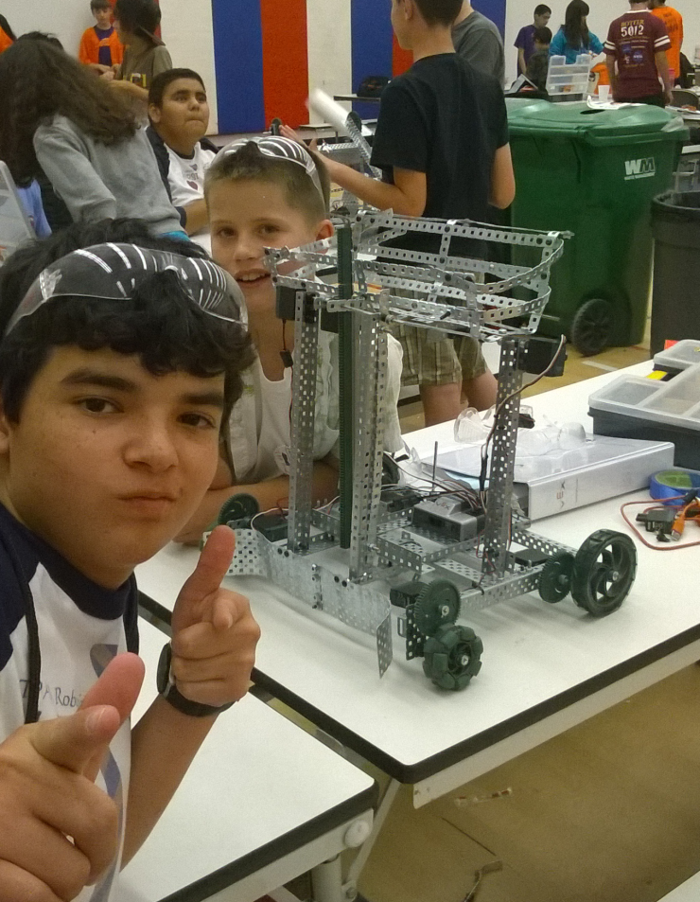

Khan's log
Star date 7/8/14
After several attempts, we have not managed to get Auto Desk to function on our computers. So in place of Auto Desk, we have chosen to continue on with our plans using the Google SketchUp CAD software that we learned how to use at a seminar given by another team from our area.
Last year's robot "Pythagoras" built in SketchUp.
